**HOW TO LOG IN IN SUPPORT TICKET:**

* 1. Go to Address bar
     1. In Address bar, type the link address ***SUPPORT.MUTIGROUP.COM***

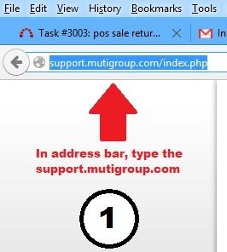

* + 1. Press Enter key

2.2 In Main Page, ***Click Open New Ticket*** as shown below.

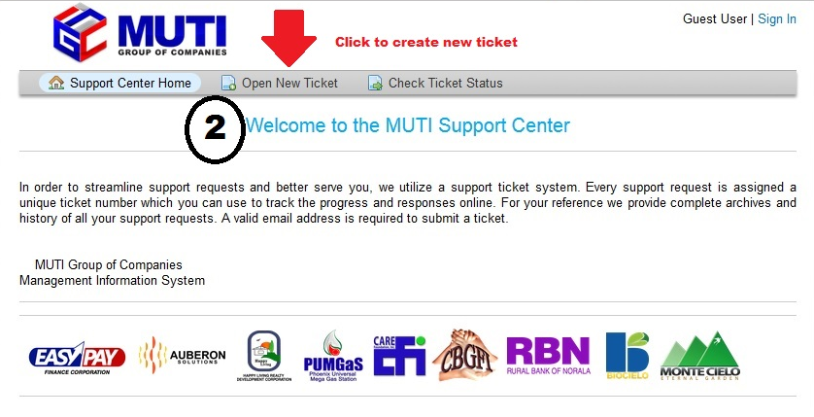

3.3 Log in using your mutigroup email account then, type your password and click Sign In button or press Enter key.

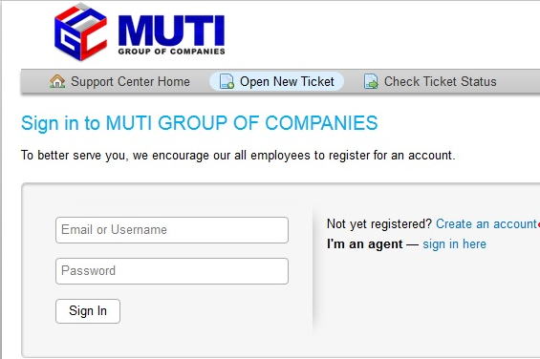

4.4 To create a new account, Click ***Create an account*** link as shown below.

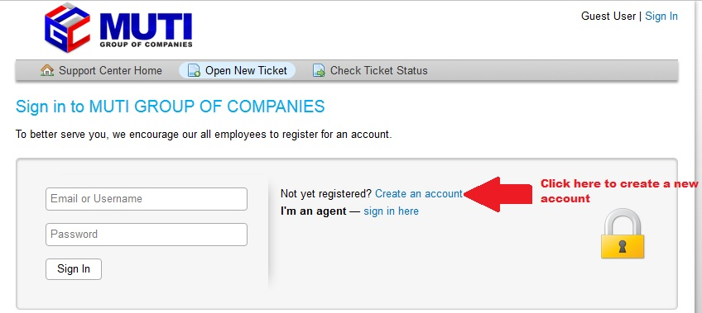

4.1 Supply the information needed on provided text box below

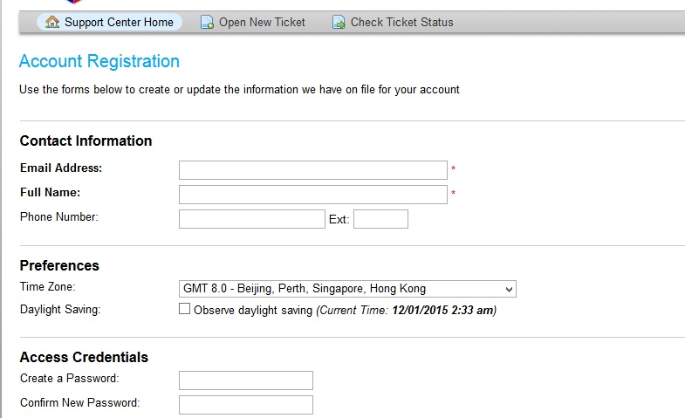

4.2 Click Register button

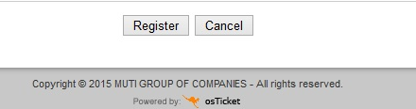

5.5 Once Log In, to create a new ticket select a ***Help Topic***.

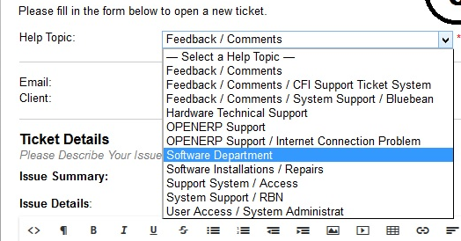

5.1 Type your issue/concern in ***Issue Summary textbox*** and ***Issue Details*** as shown below.

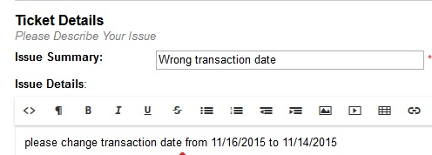

5.2 If you have some files to attached, click ***Browse button*** set ***Priority Level***, type your ***Employees Name*** and ***Branch/Department***, ***Contact Number*** and click ***Create Ticket button***.

